Ques 2 : Apply branch policies such that only the project administrator can access the master branch; contributors cannot.

Soln:

Branch policies in Azure DevOps help control who can push, merge, or delete branches. In real projects, the master or main branch usually holds production-ready code, so it must be protected. By restricting it to only Project Administrators, we prevent accidental changes by contributors. This ensures code quality and deployment stability. It’s a crucial part of secure DevOps practices.

IMPLEMENTATION STEPS: RESTRICT MASTER BRANCH ACCESS

Step 1: Navigate to the Branches Section
- Go to your Azure DevOps Project.
- Select Repos > Branches.
- Locate the master (or main) branch.
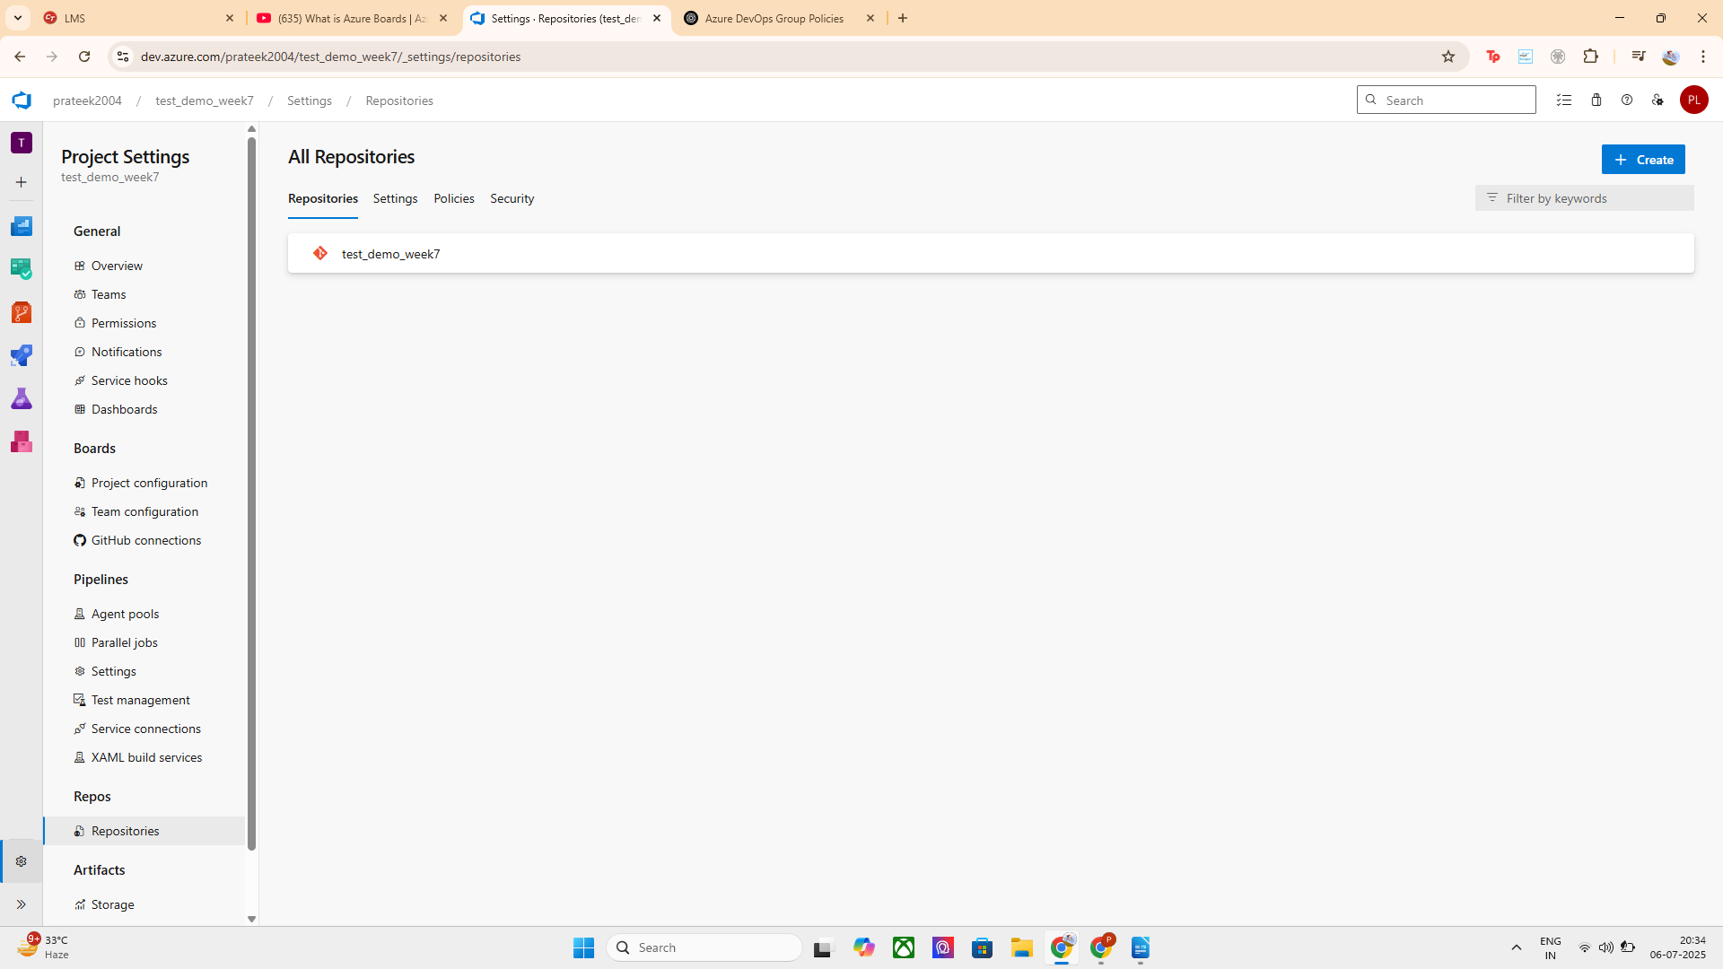

Step 2: Locate the master (or main) branch
- Hover over the branch row
- Click on the three dots (⋯) → select Branch security

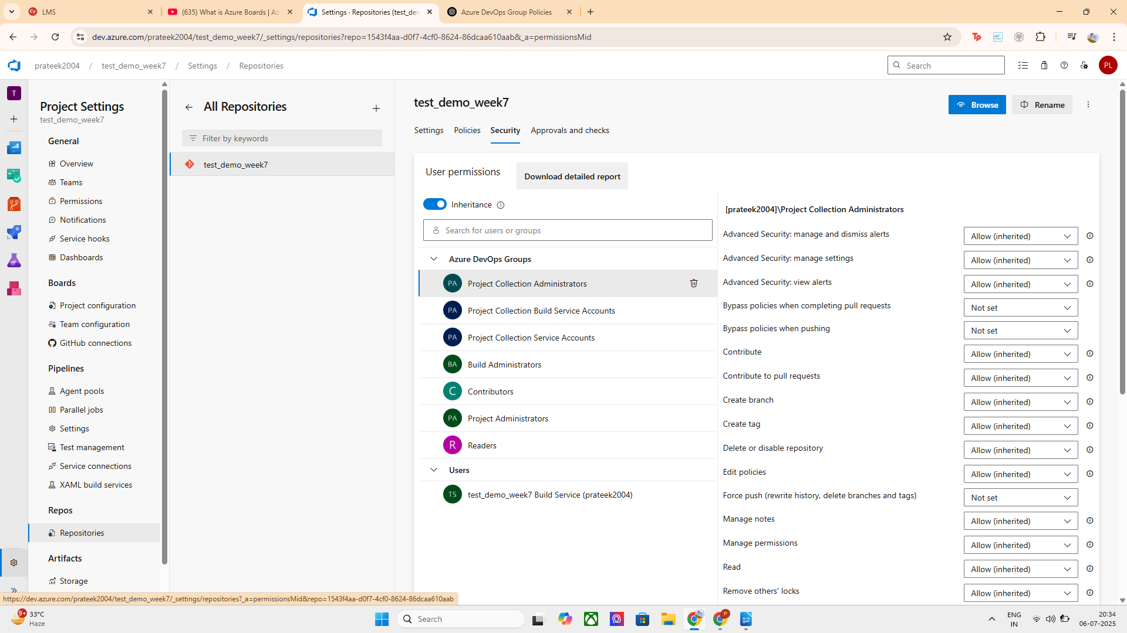
SELECT THE PREFERED BRANCHES:
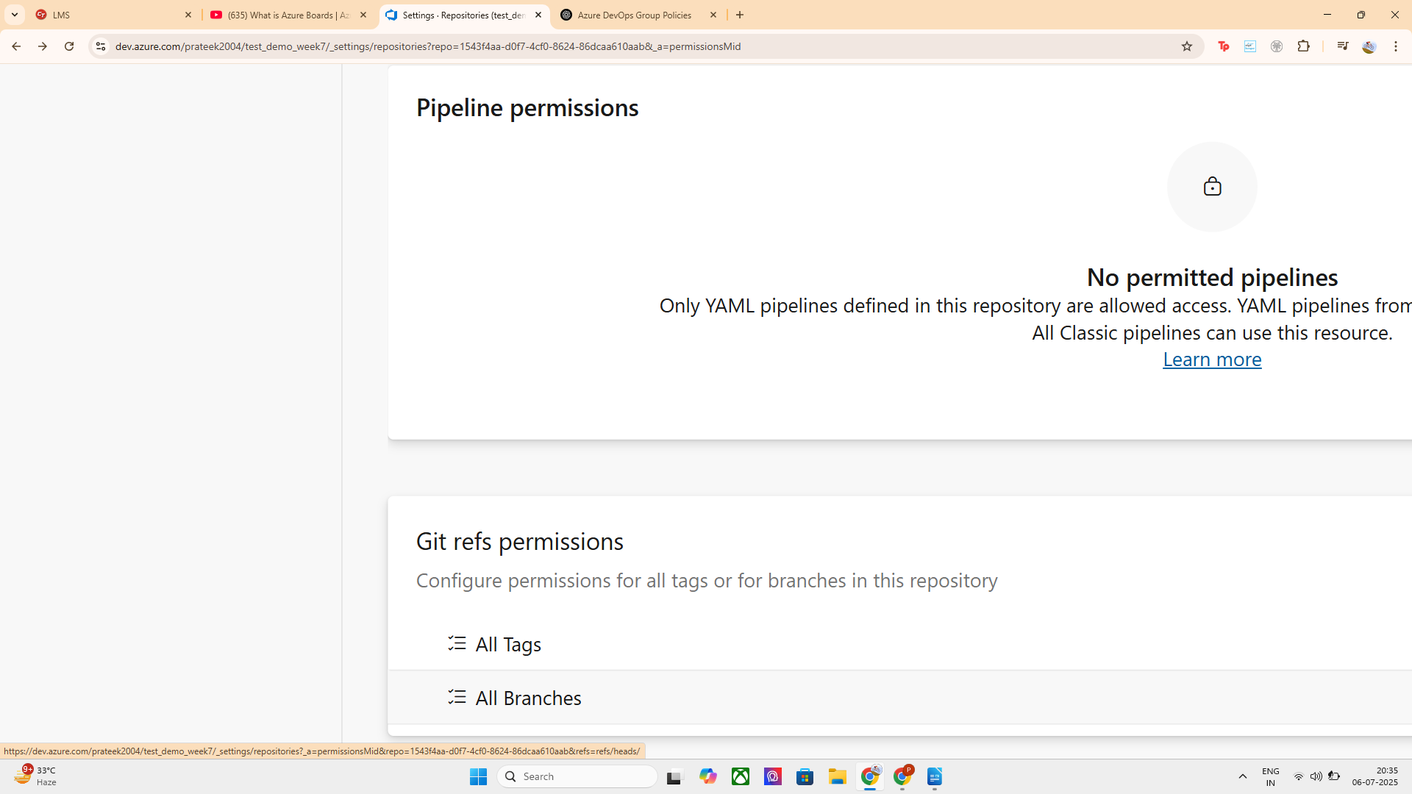
POLICY CONFIGURATION TAB WILL BE OPENED:

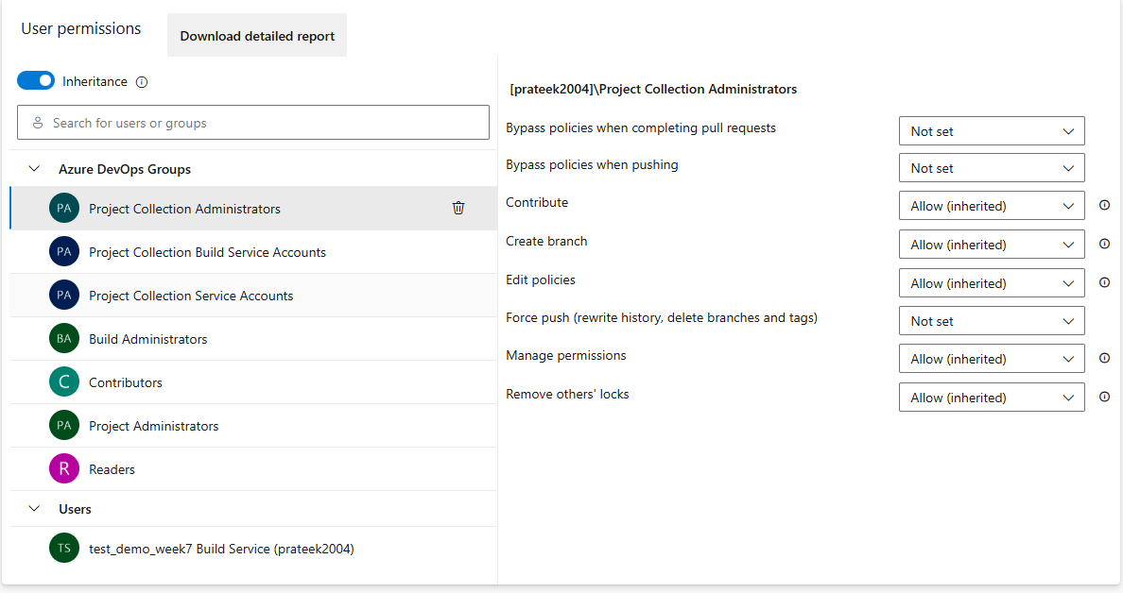

GO TO CONTRIBUTERS GROUPS AND EDIT THE PERMISSIONS AS
only the project administrator can access the master branch; contributors cannot :

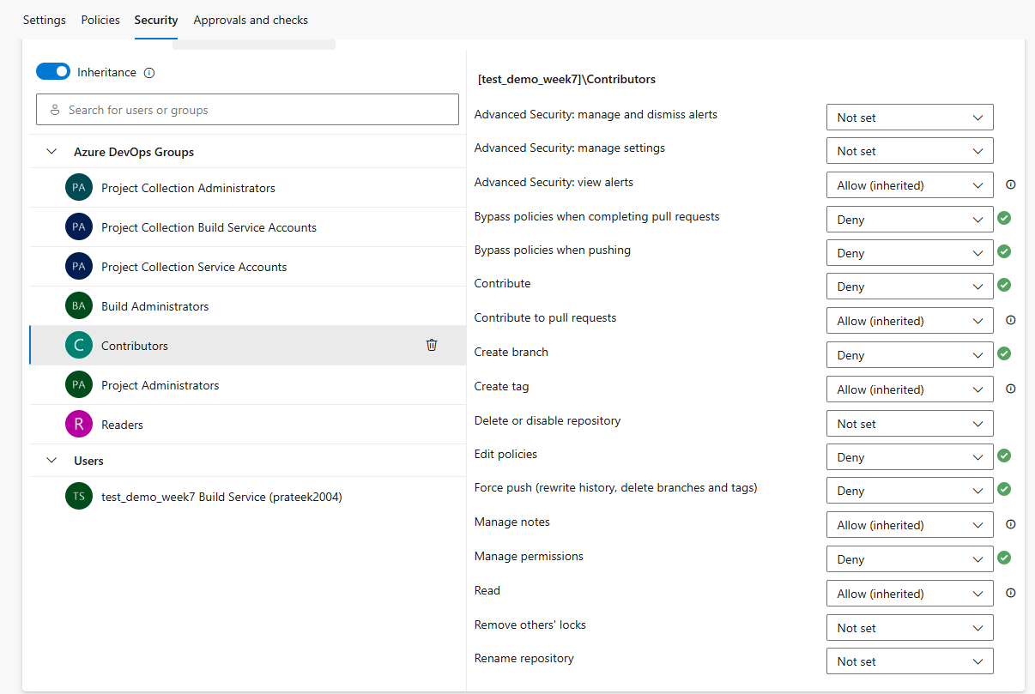

DETAILED EXPLANATION OF PERMISSIONS :

Permission Name | Purpose / Description | What You Should Do
Advanced Security: manage and dismiss alerts | Manage security alerts (e.g., secret scanning, vulnerabilities) | Not relevant for branch control
Advanced Security: manage settings | Change security scanning configurations | Not required now
Advanced Security: view alerts | View code scanning alerts | Not needed for access control
Bypass policies when completing pull requests | Ignore required policies (e.g., reviewers) when completing PRs | ✅ Allow for Admins only
Bypass policies when pushing | Push code without enforcing policies | ✅ Allow for Admins only
Contribute | Push changes (commits) to the branch | ❌ Deny for Contributors✅ Allow for Project Admins
Contribute to pull requests | Comment or review in pull requests | Optional – usually leave as Allow
Create branch | Make a new branch from this branch | ❌ Optional to deny for Contributors
Create tag | Tag commits (used in releases) | Optional
Delete or disable repository | Delete the whole repo | Not branch-related
Edit policies | Change branch policies (like reviewers) | ✅ Allow only for Admins
Force push (rewrite history, delete branches and tags) | Overwrite commit history, delete branches | ❌ Deny for Contributors✅ Allow for Admins (if needed)
Manage notes | Add/edit Git notes | Optional
Manage permissions | Change security settings | ✅ Allow only for Admins
Read | View code | ✅ Allow for all groups
Remove others' locks | Unlock files locked by others | Optional
Rename repository | Change repo name | Not branch-specific

Step 2: Allow Only Project Administrators :

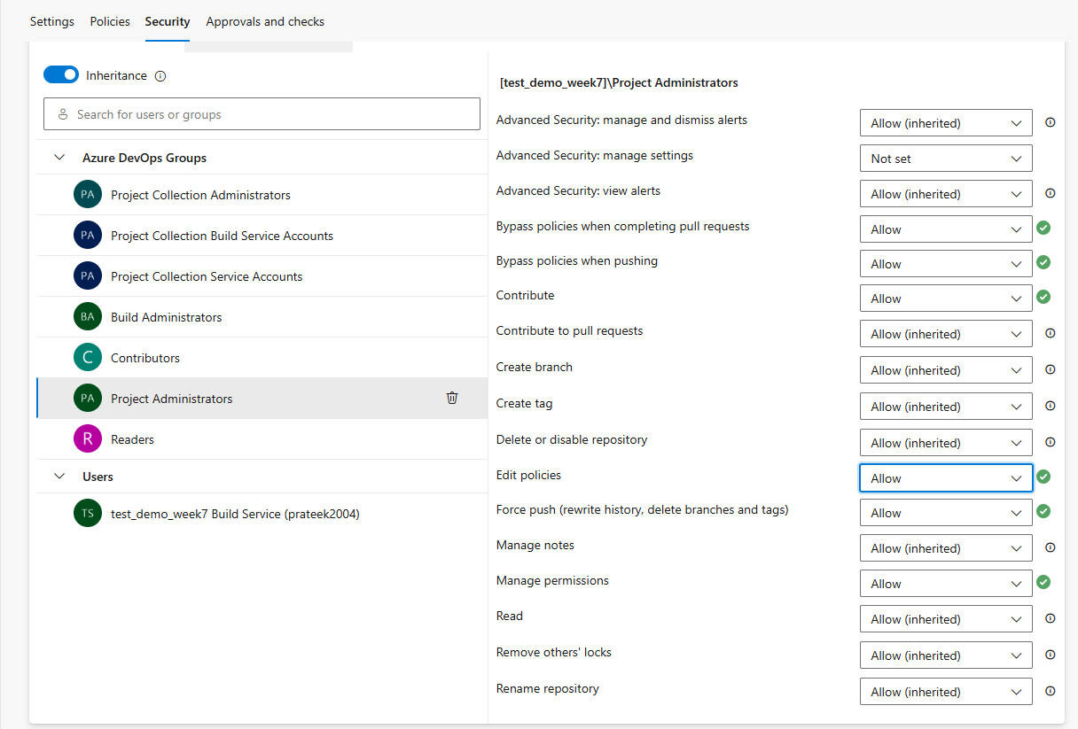

Step 4: Save Changes
- Click Save at the bottom or top if it appears.

Test It!
Ask a contributor (non-admin) to try pushing to master:
- They should see a permission denied error.
- Admins should be able to push without issue.

HENCE ITS SUCCESSFULLY CONFIGURED

Task | Status
Created a project in Azure DevOps | ✅ Done
Navigated to branch-level security (refs/heads/master) | ✅ Done
Denied Contribute permission to Contributors group | ✅ Done
Allowed Contribute (and optional Force Push) to Project Administrators | ✅ Done
Verified policies in Git Refs Permissions | ✅ Done
Understood Build Admin and Project Collection Admin are not suitable here | ✅ Done

Final State of Access Control
Group | Contribute | Access to master
Project Administrators | ✅ Allow | ✅ Full access
Contributors | ❌ Deny | ❌ No access

